BACON IS BACK !! The order will be placed ( FEB 25 9am )
With Pick up ( in Service ) on ( FEB 26 )(4-8)
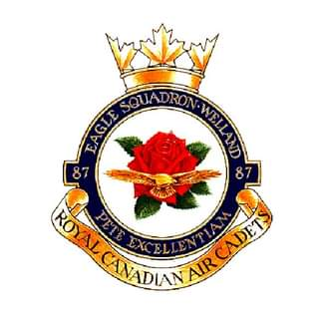
This fundraiser supports the Welland Air Cadets. COVID has made this a primary source of fundraising. Your much needed support is greatly appreciated
Order pick-up must be Friday Feb26 between 4-8pm at Canadian Tire Auto Service. We do not have storage.
Please see Rob Foster at Canadian Tire in Service with your order and full payment. Cheques can be made payable to Robert Foster who is administrating this fundraiser
Post dated cheques will be refused.
