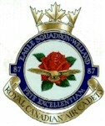

87 Eagle Squadron Picture Night
Wednesday, October 26, 2016

Dear Parents/Guardians

The Squadron has made arrangements to have a photographer come in and take military style pictures of each individual cadet as well as a squadron group photo on Wednesday, October 26, 2016. These pictures are great Christmas gift ideas for grandparents, family and friends.

Your CD will include both an image (outline around image with squadron crest, cadet rank and name and note of any special medals) and a regular image similar to those below that you can print as many copies of as you need.

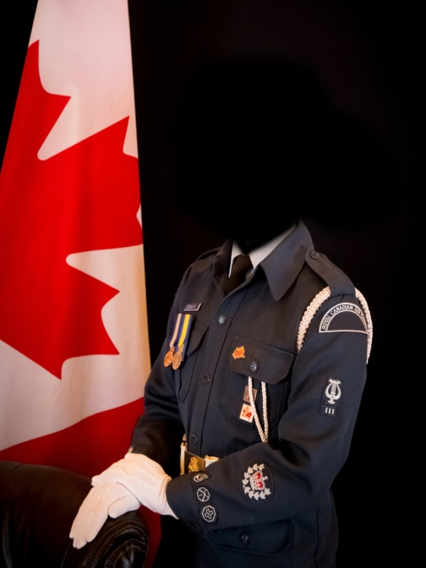
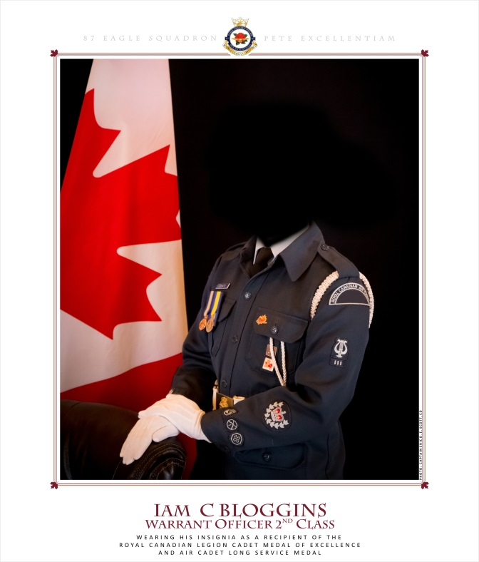

Orders must be paid for on the night of the pictures (cash only please).
Please complete the attached order form and bring it with you on October 26, 2016.
Should you have any questions, please speak with the Commanding Officer, Captain Norio.

A M Norio, CD Mrs. V. Kalenuik
Commanding Officer Sponsoring Committee Chair
PICTURE ORDER FORM

CADET NAME:
(name and initial as to appear on picture)
ORDER:

- CD (includes two (2) images with outline and without) $20.00

- CD (same as above and one (1) 8x10 print) $25.00
- Print to include outline
- Print no outline

FOR CADETS WITH SIBLINGS IN THE SQUADRON:

- FAMILY CD $30.00
(includes individual images and family images with and without outline – same as regular CD)

- FAMILY CD $45.00
(includes individual and family images with and without outline and a print of each individual and one family)
- Prints to include outline
- Prints no outline

CASH ONLY PLEASE.

Special Instructions:

